**Movie Time Documentation**

Following is the detailed documentation of the Movie Time web app.

* For setup requirements.txt file is given with project.
* After installing requirements and starting server (python manage.py runserver)
* Go to the url : [http://localhost:8000/](http://localhost:8000/movies/)

1. **Login Page:**

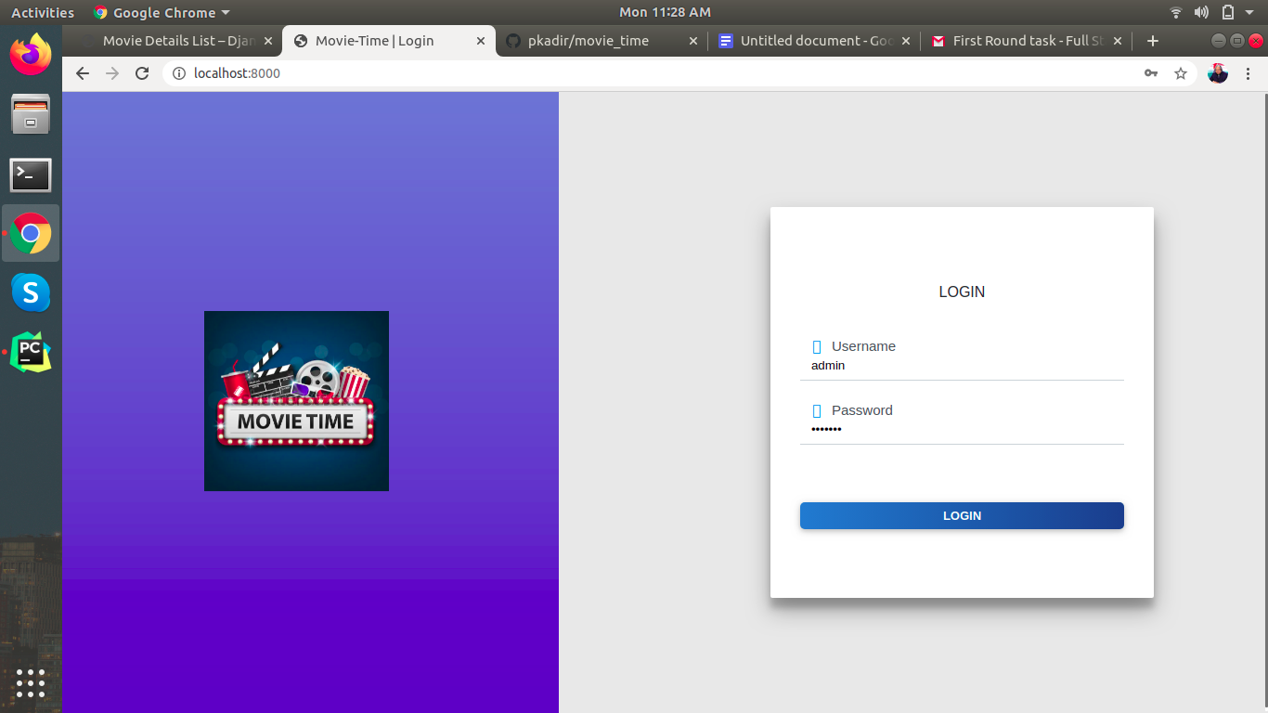

* 1. Normal user
  2. Admin user

1. **Home page:**

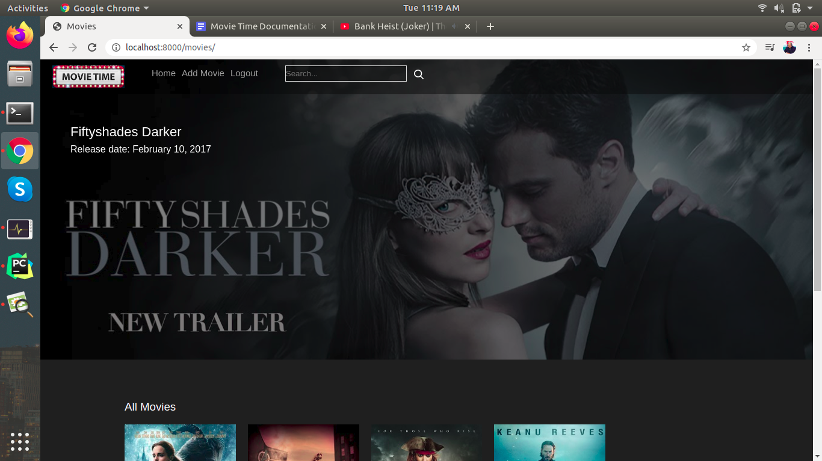

On home page Admin can access add movie option which normal user can't.

1. **Display all Movies:**

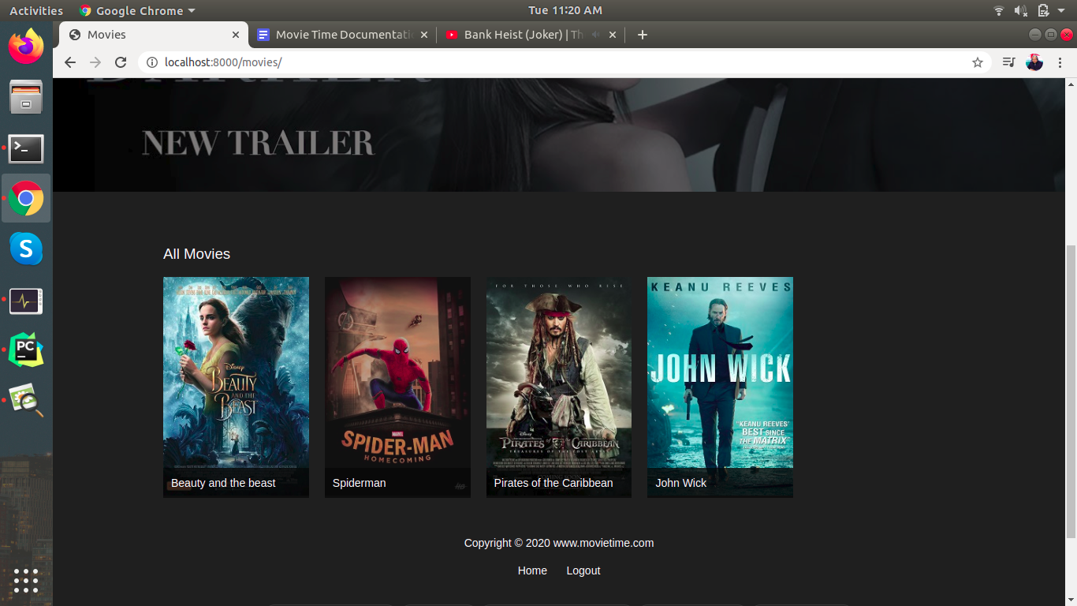

1. **Details of one movie:**

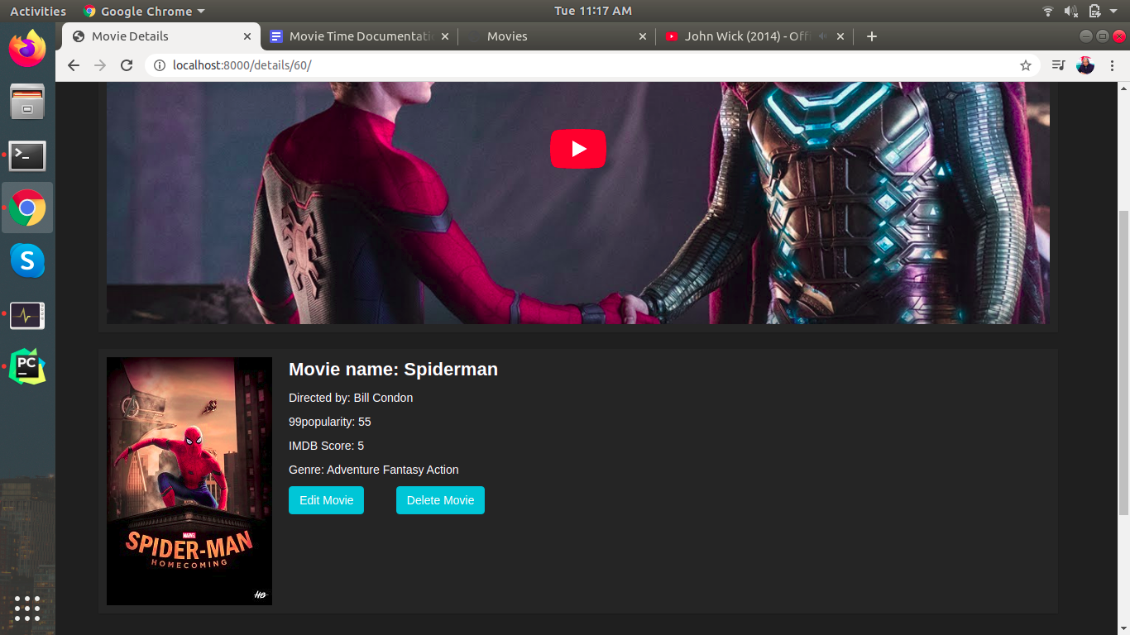

1. **Add new movie:**

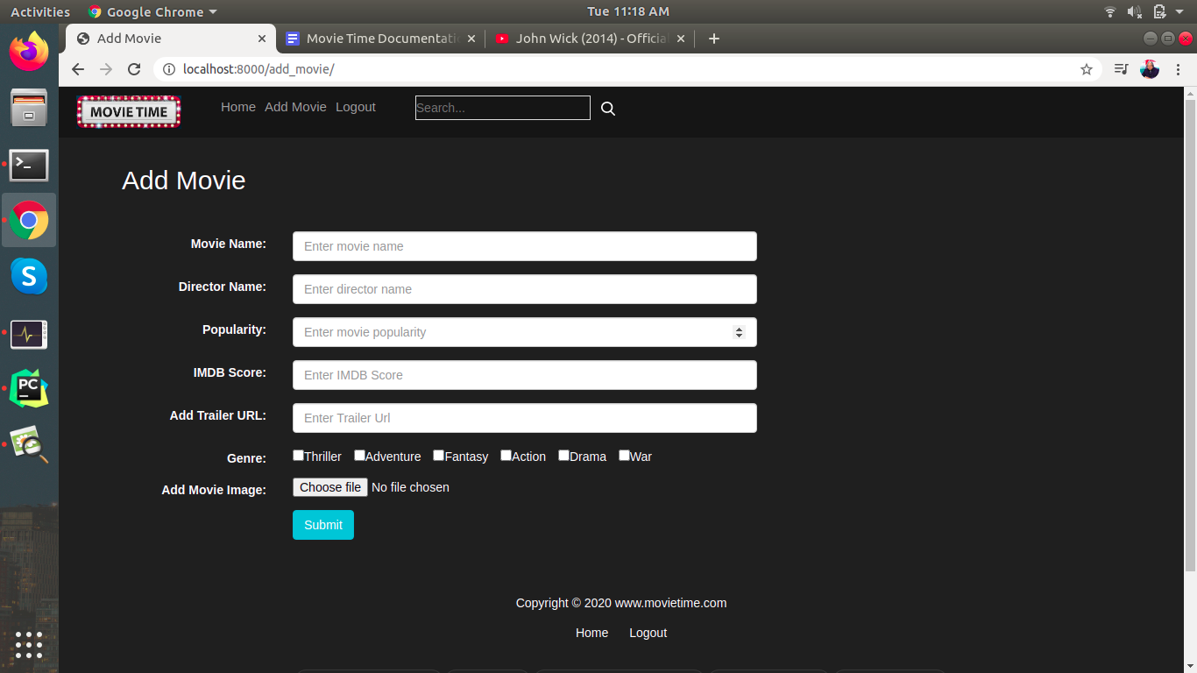

Only Admin can add new movies and have access to the above page.

1. **Rest API for movie details**
   1. **Go to the following link for API:**

<http://localhost:8000/api/movie_details/>

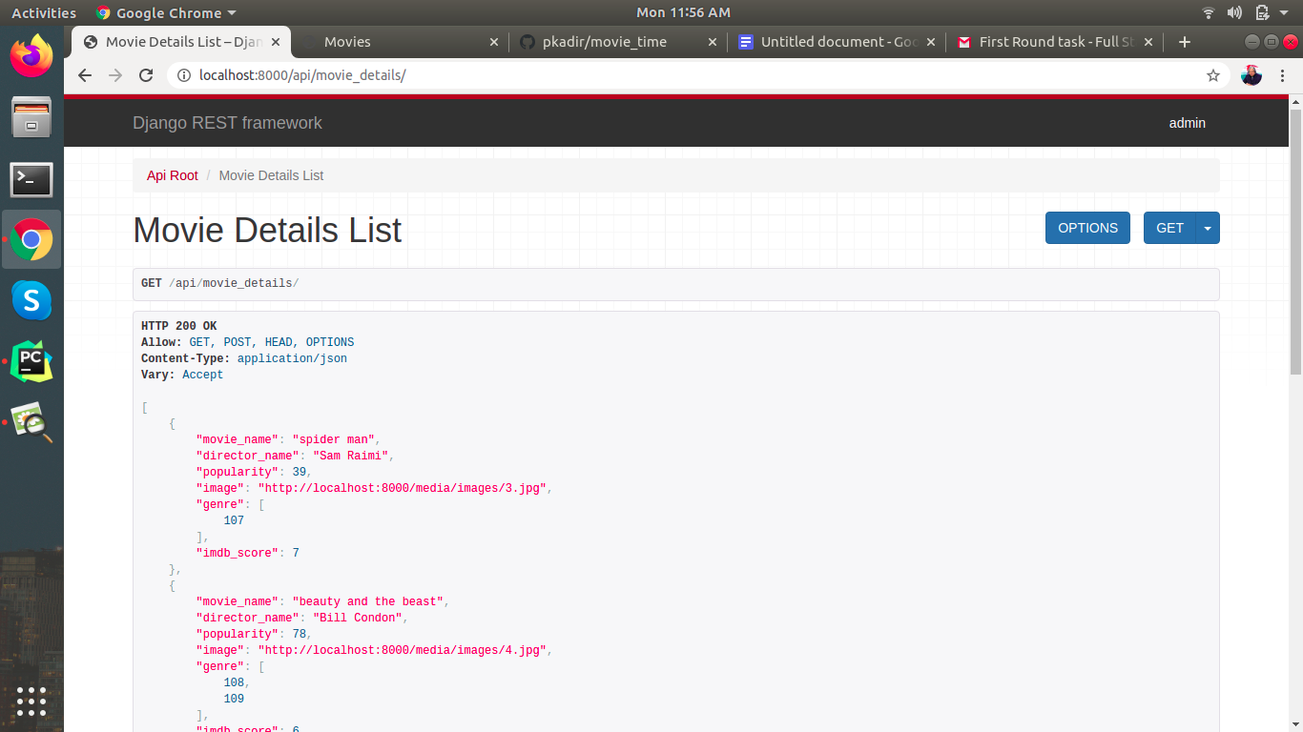

1. **Delete Movie:**

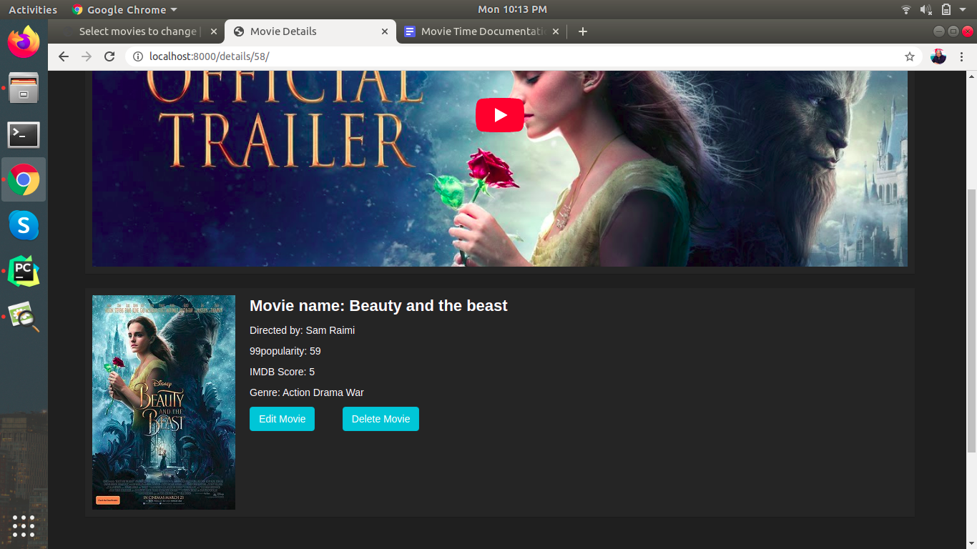

By clicking on the Delete movie button only the admin can delete movies, normal users can’t access this feature.

Following is the image normal user logged in and visited same page:

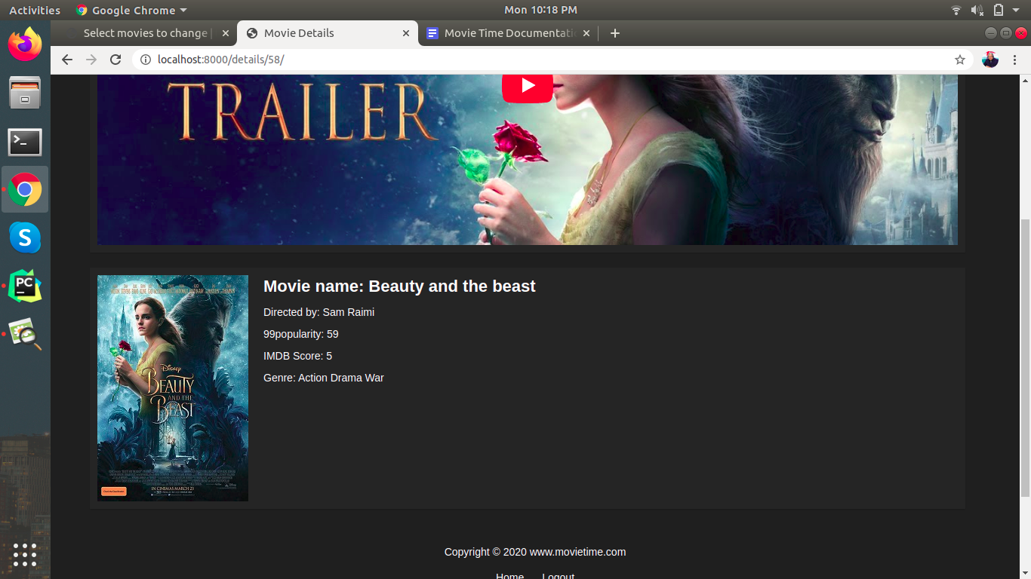

1. **Edit Movie:**

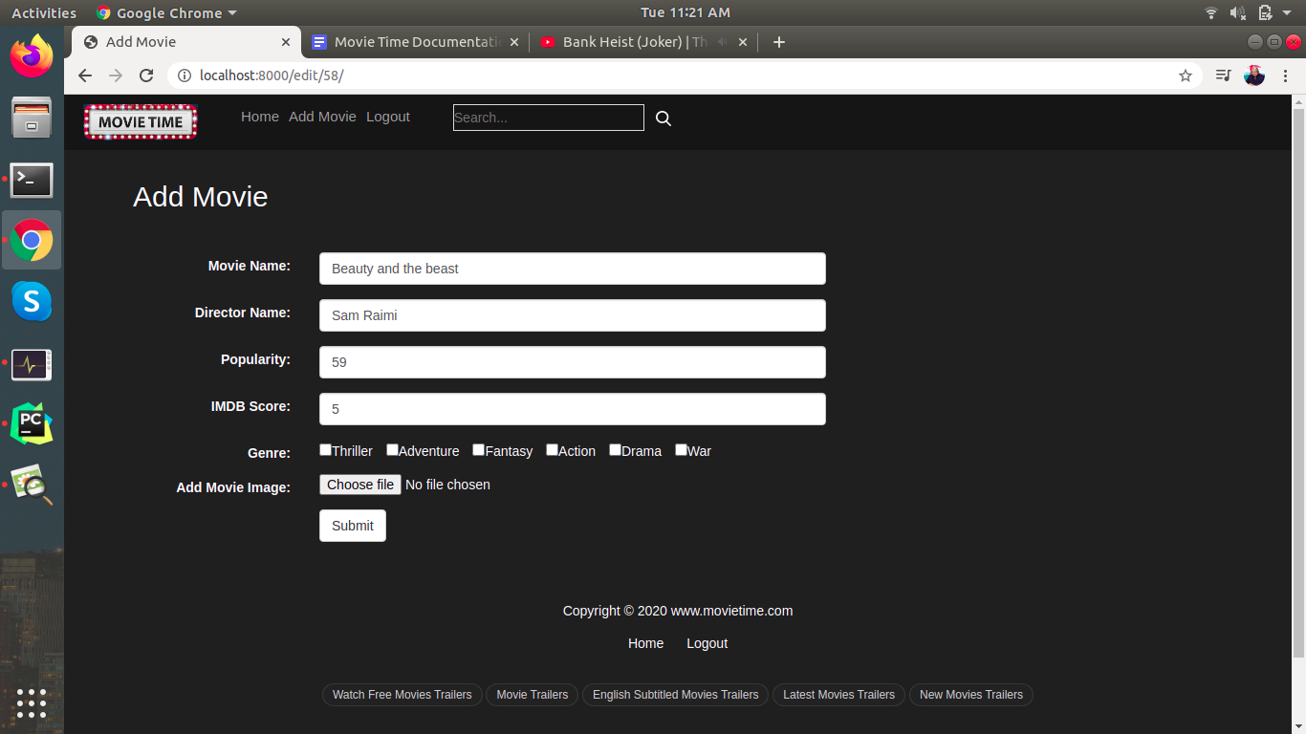

Only Admin can edit movie details

1. **Search Movie:**

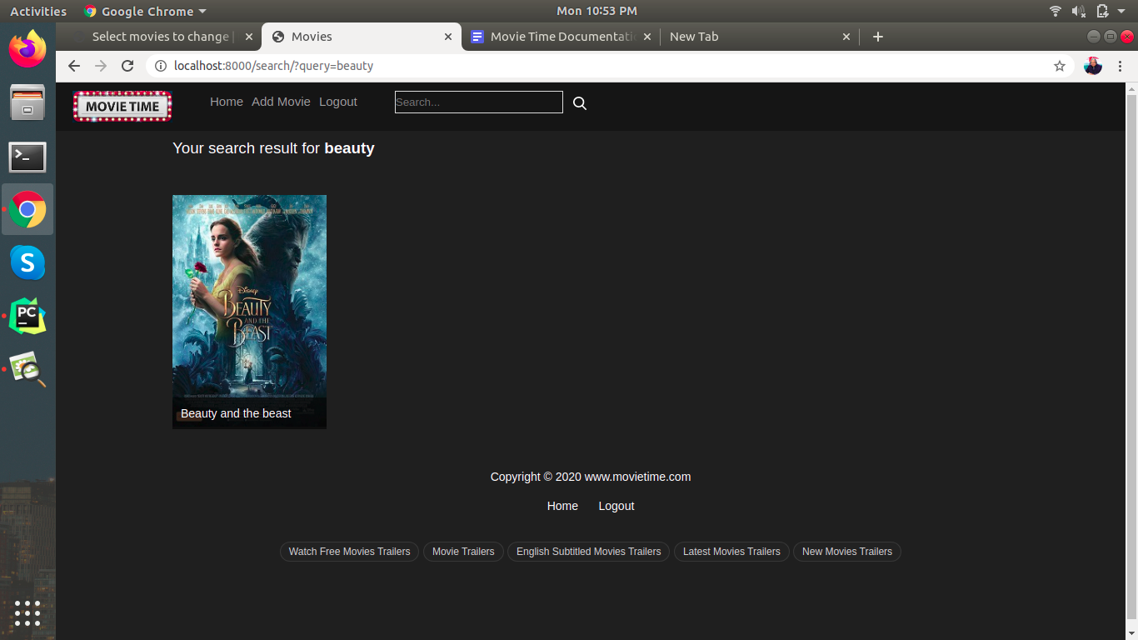

User can search movies from any page by providing **Movie name** or **Director name**

1. **Show movie trailer from youtube:**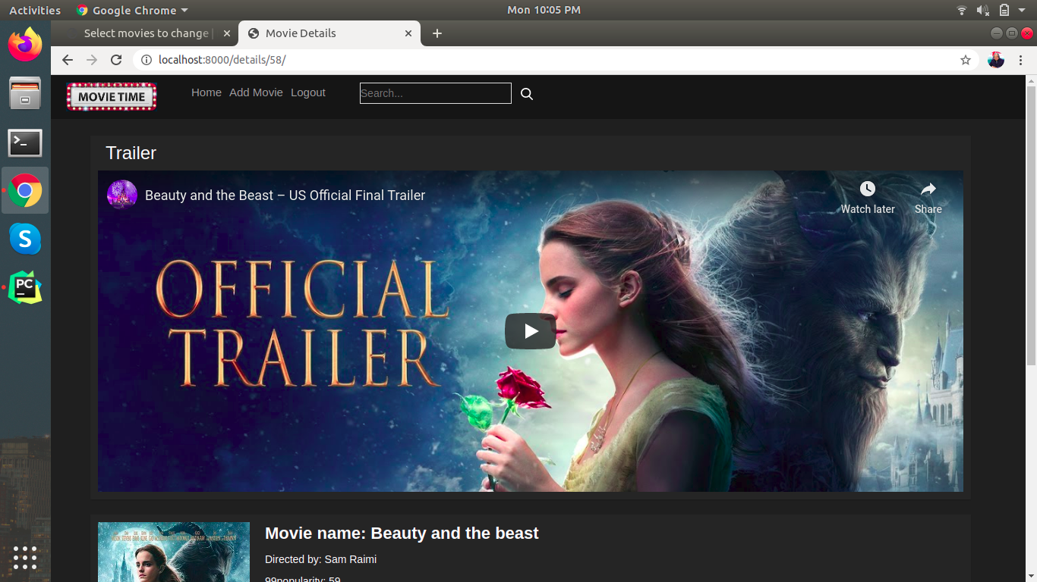

Here we can show a trailer of a movie by adding a youtube url while adding a new movie.

1. **Carousel to show latest movies:**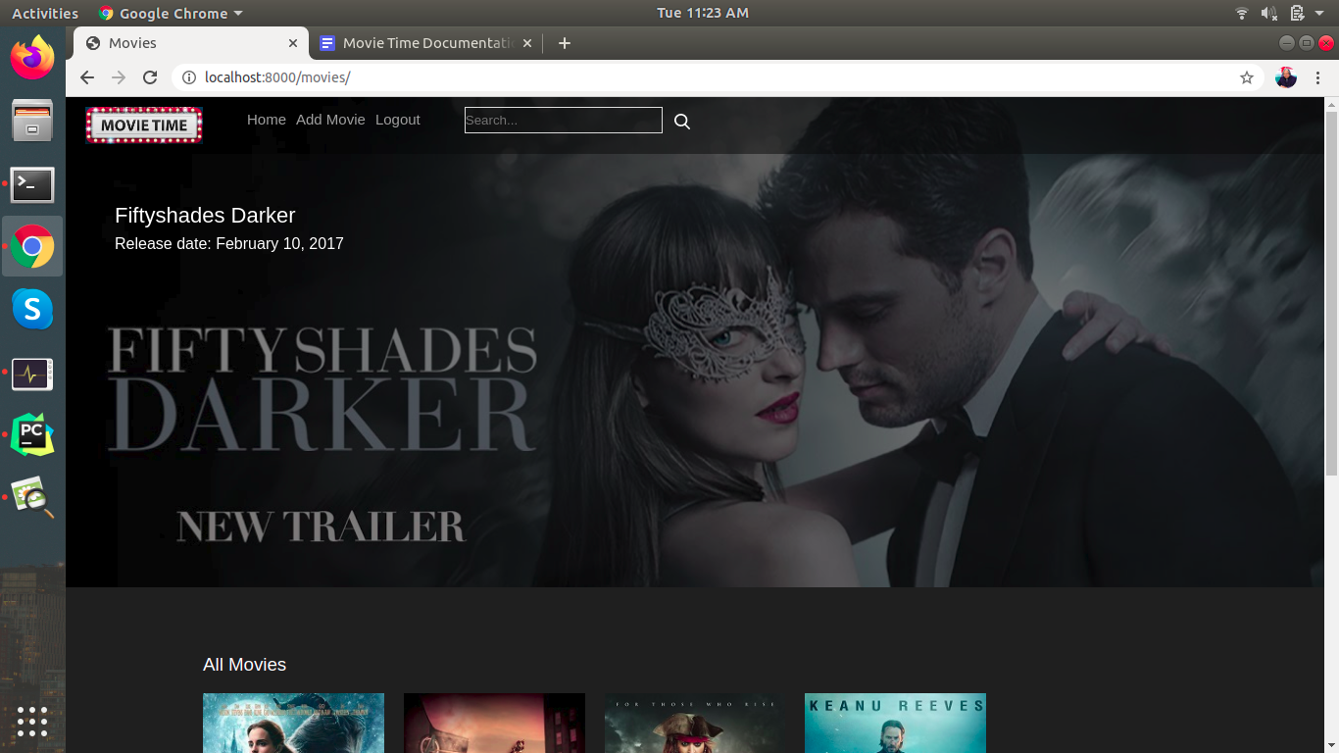

In this carousel I am showing latest movies which will be added by Admin - Currently it’s static